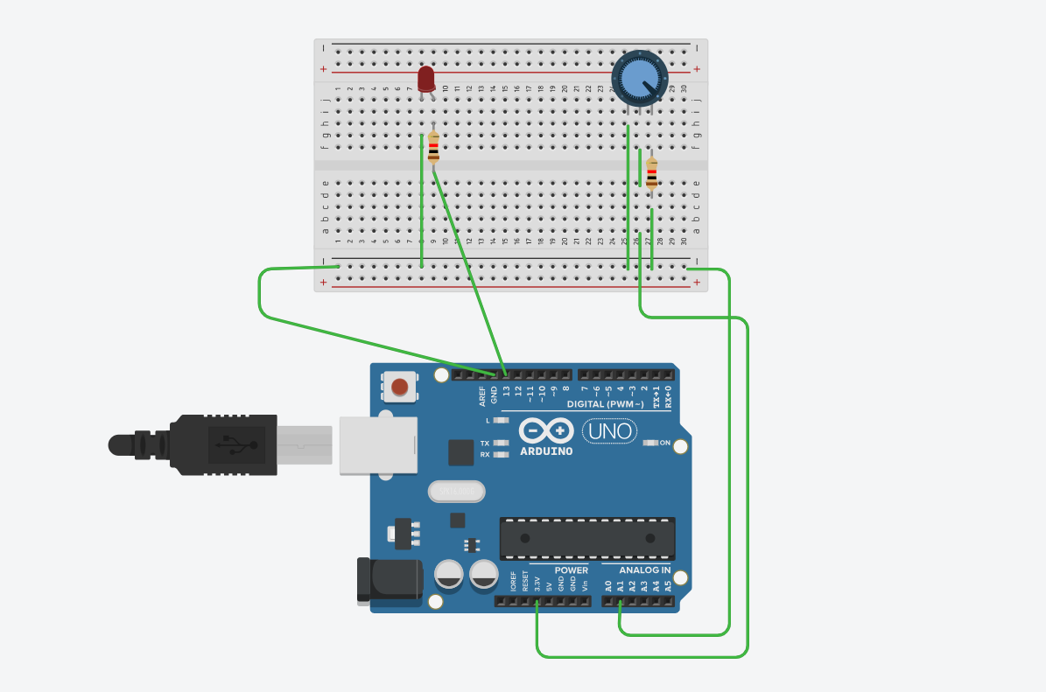
const int ldrpin = A1;
const int ledpin = 13;

void setup()
{
pinMode(ledpin, OUTPUT);
}

void loop(){
int lrdvalue = analogRead(ldrpin);
int ledvalue = map(lrdvalue, 0,1023,0,255);
analogWrite(ledpin, ledvalue);
}

